Team Name and Number _______________________________________________________________

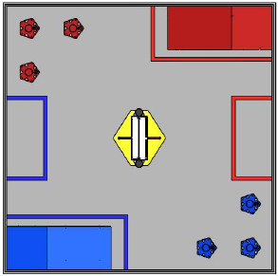Match # __________ Alliance partner ______________ Scouted by _____________________________

**Autonomous**

(Sketch path on figure to right)

**Ramp** **Floor**

**Balls released**: Yes No

**Spinner position**: 1 2 3

**Tubes scored**: 30 60 90 120

**Tubes returned to base**: 30 60 90

**Notes**

________________________________________________________________________________________________________________________________________________

________________________

**Tele-op**

**Large balls scored** ____________ **Small balls scored** ____________

**Tubes scored:** 30 60 90

**Primary Tube(s**): 30 60 90

**Tubes returned to base**: 30 60 90

**Able to score in 120:** YesNo

**Number of balls scored in 120** _________

**Maneuverability**: Poor Fair Good Great

**Speed**: Slow Average Fast

**Teamwork**: 0 1 2 3 4 5

**Win Loss**